Questions and bugs from 3.8.26 – Testing for 360 ONLY
Summary of issues
- Assignment email template removal of extra white space , and only one ‘Logo per assessment’ even if multiple have been assigned. See email I sent you on 3.8.26.
- Weird message – can’t submit assignment for someone else. I think this is a browser issue – cookies, cache, permissions … email forward to you from me and David on 3.8.26.
- Response styling needs an updated design (phase 4) to match the preferred, more polished layout shown in the reference screenshot.
- Remove ‘My Profile’ element for standard user profiles.
- Need ability to edit assignments for an entire survey (extend deadlines, delete assignments, etc.), This is done for individuals, but what about THE ENTIRE survey? Change a date for everyone in it?
- For the bulk-report feature, status/readiness is unclear; need a way to know when reports are ready and ideally download them as a zipped folder rather than individually.
- We advancing through 360 as user, when you click next and it goes to next page, it does not start at top of next page, it starts at competency name. Seems odd. Lets fix so starts at top of page. See recording in Slack.

Below are screenshots and more detail to support these bullets
Yellow highlight known bug/issue’ Green highlight, new; Blue – notes to you

Email template for assignments: - Still needs a bit of tweaking with white space .
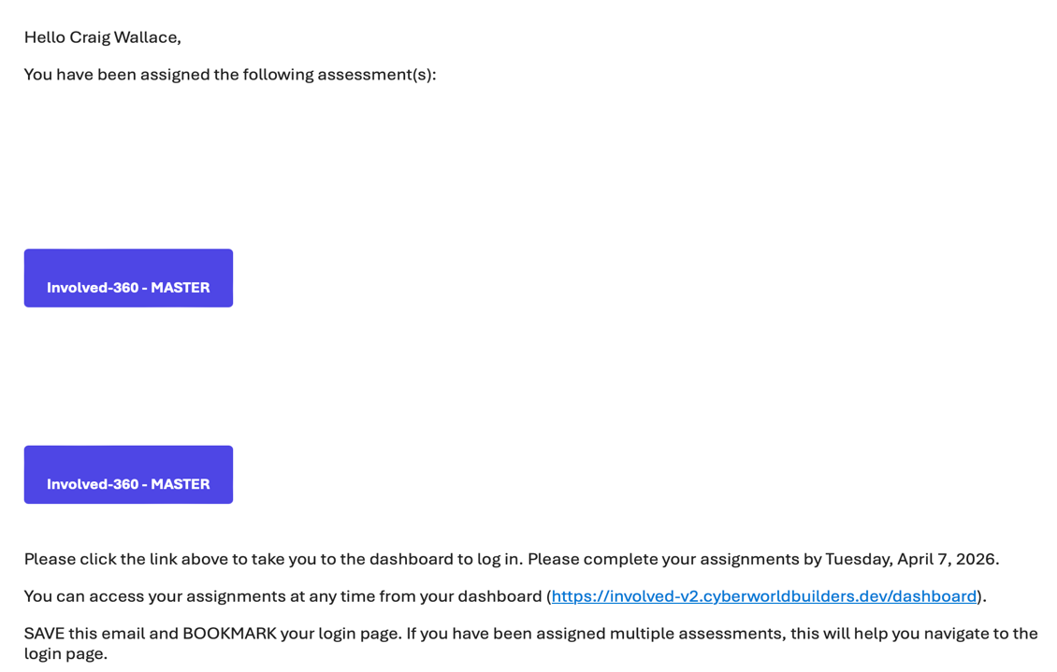
Only 1 button with one assessment name… see email I forward you on this
Remove this white space

Styling for responses – can be phase 4: Time to do this
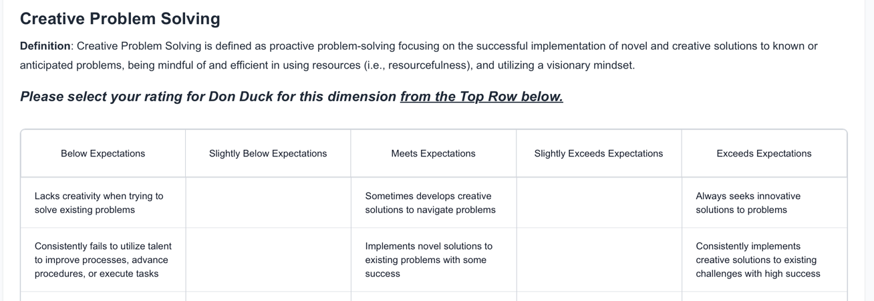
MORE LIKE THIS: (below)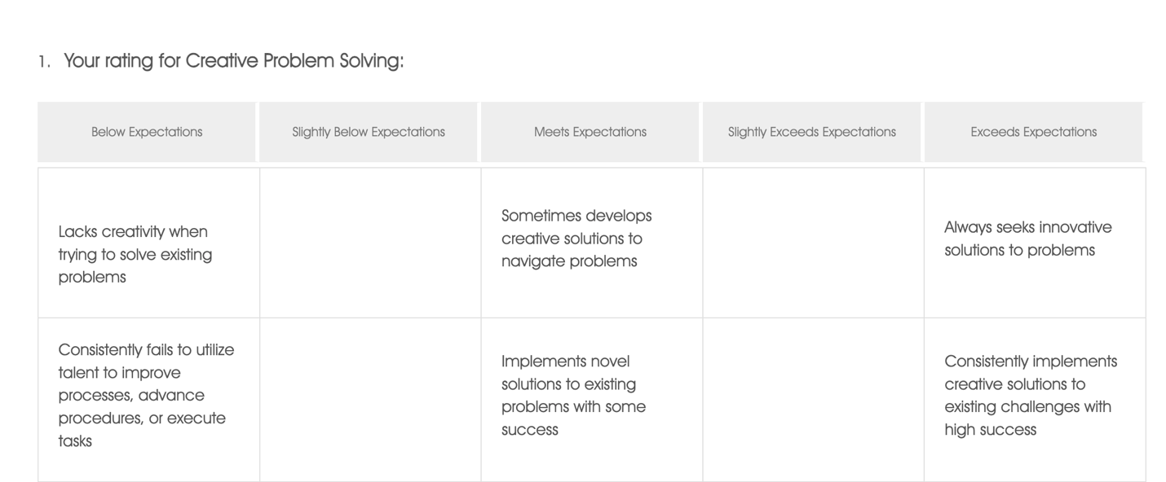

Remove/Hide Profile section for users.
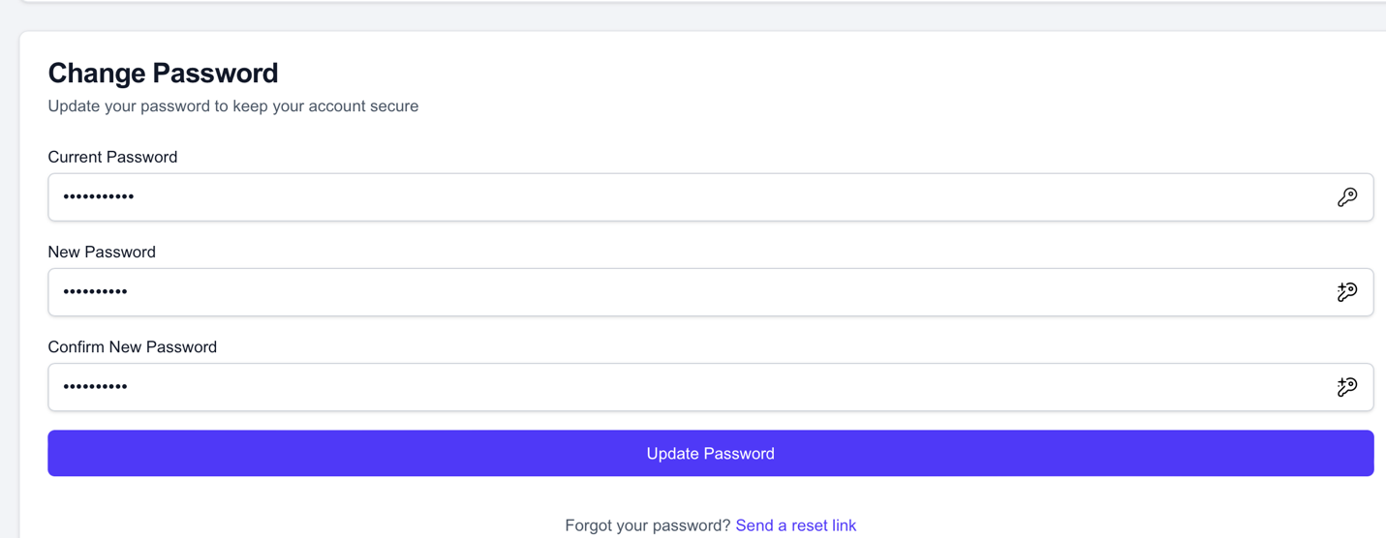
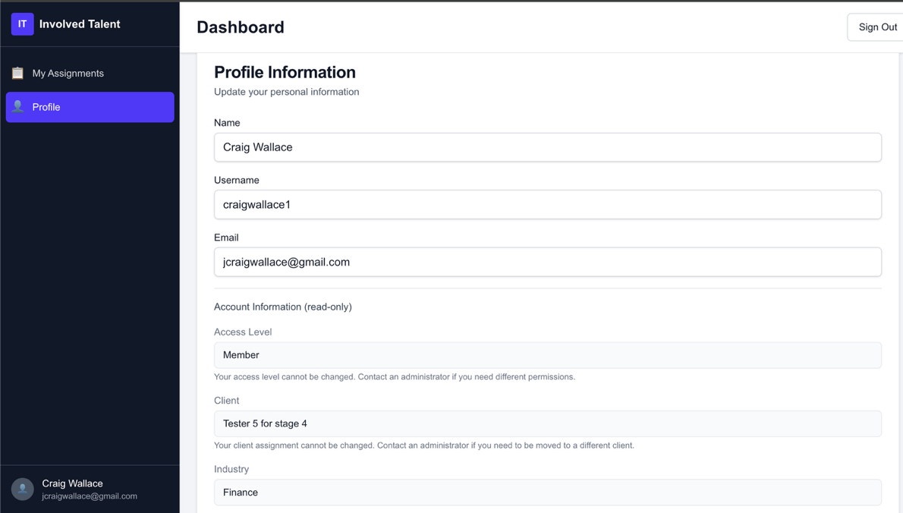

Reports:
Regenerate PDF does not seem to work right.
Weird workflow – Had to click into each view report, then click regenerate report, then regenerate pdf. Could not seem to get the Regenerate PDF to do anything unless I went through these steps.

Remove this header from all PDF reports
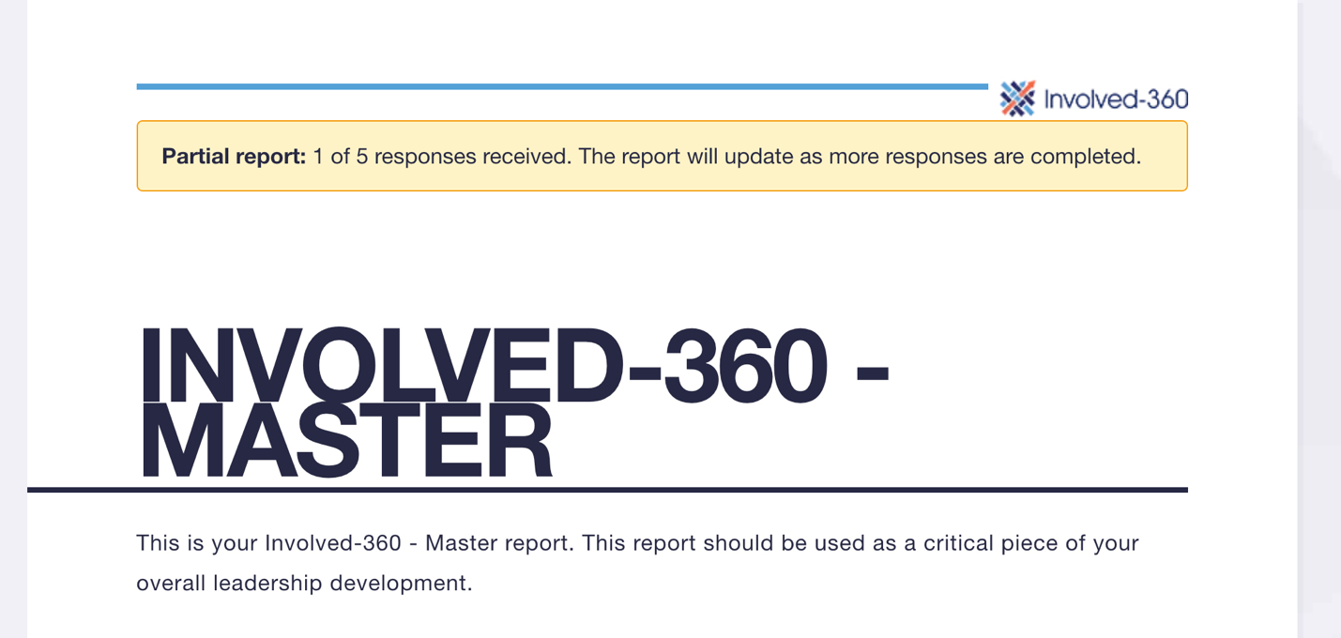

- Need to edit dates for ENTIRE survey, not just by person. In other words, how can I change due date for the entire 360, all users?

- I found the edit, by person, but as we grow this, let’s think of a way to make this more efficient.
- EDIT LIKE ON THIS PAGE: - Can push to later development.
- 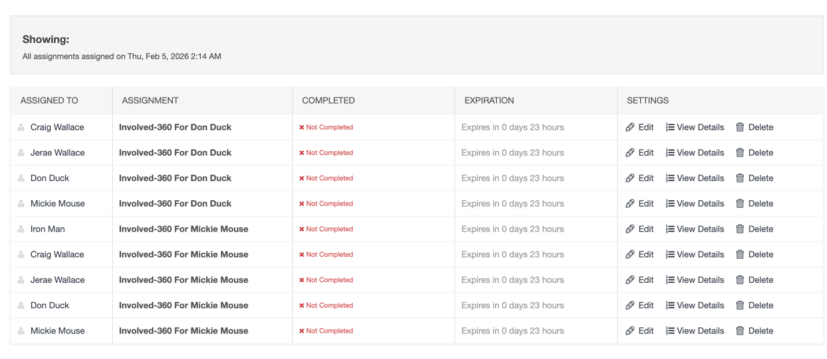

Zipped PDFs are not working correctly. – Still pending
Could not get the ZIP Export to work right. I think it was more related to creating PDFs. The Zipped folder that downloads is empty and you get an error as such.
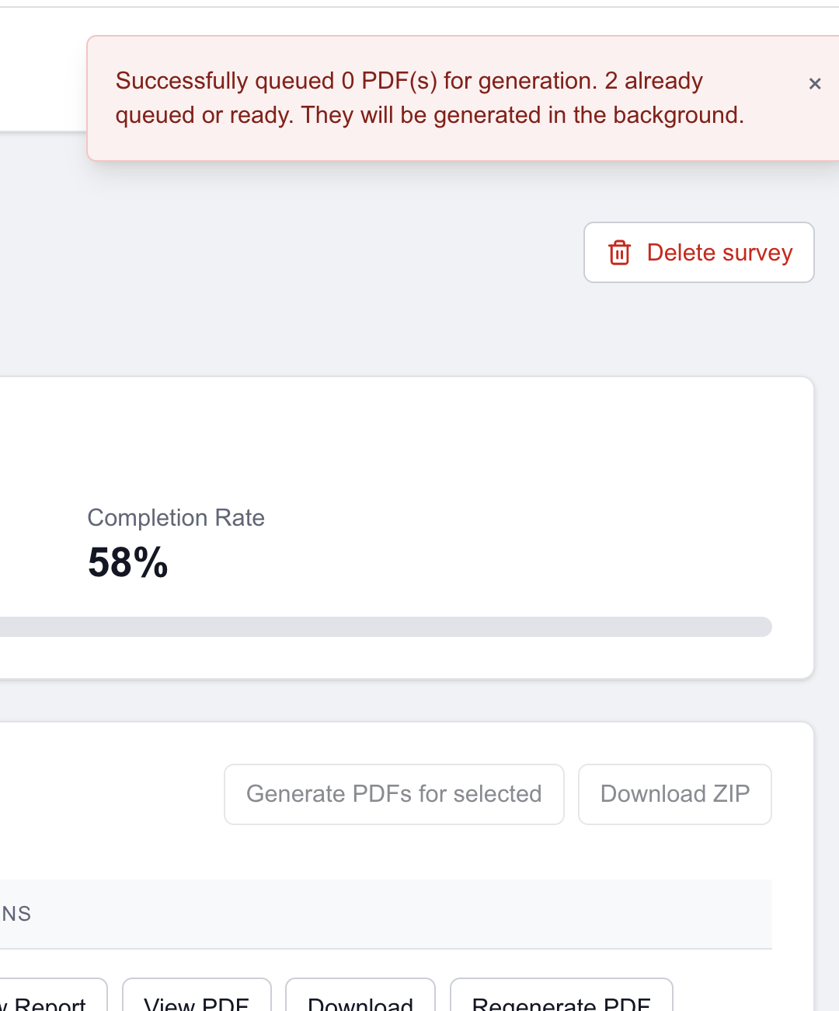

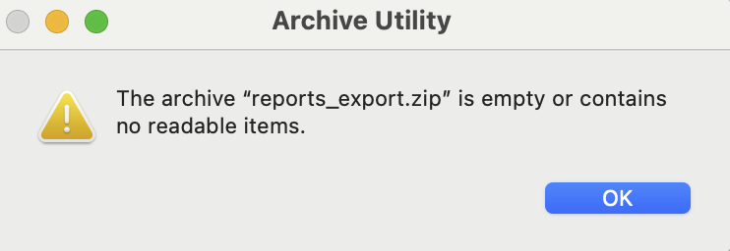
360 Reports: - see scanned version with my notes in Slack and below…

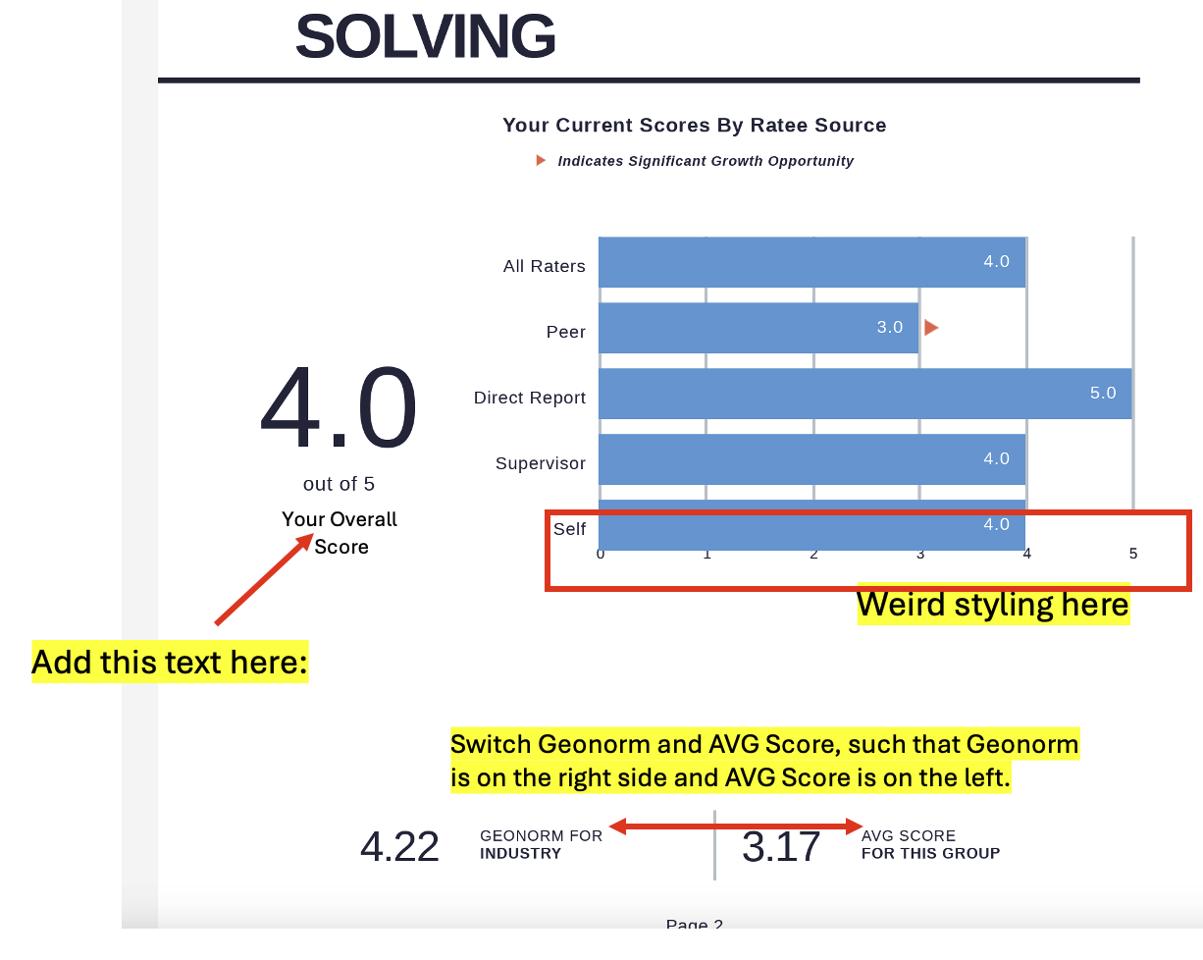

Competency Definitions – discuss with Jay
- Add appendix with competency definitions – Short-term fix
- Put competency definitions in the report under the name of each competency, where scores are graphed on tables.

